**Terraform Assignment - 3**

You have been asked to:

● Destroy the previous deployment

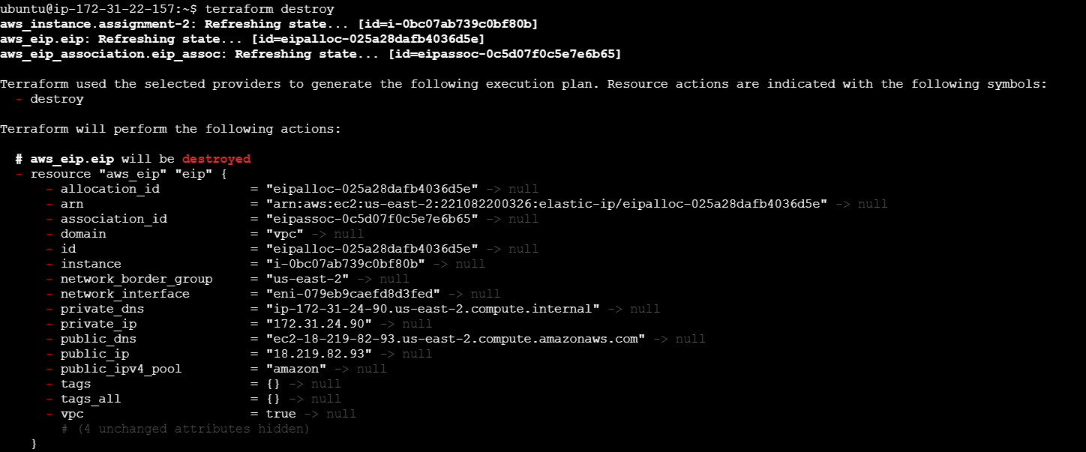

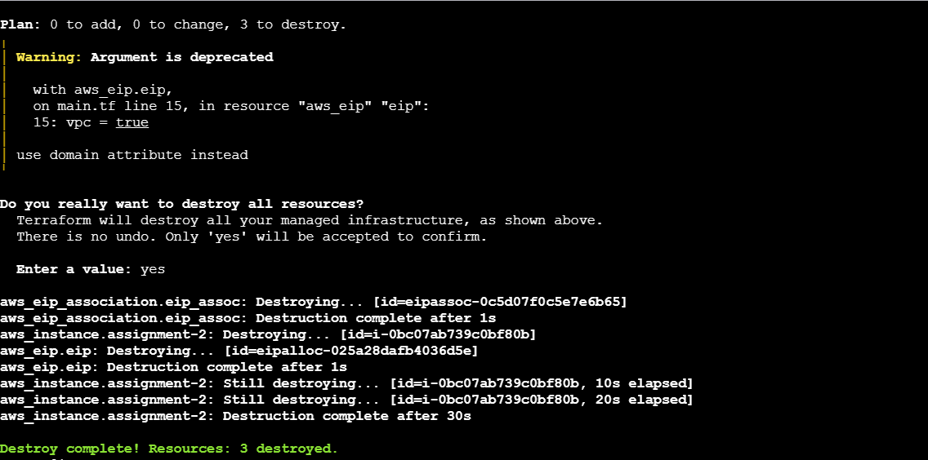

● Create 2 EC2 instances in Ohio and N.Virginia respectively

● Rename Ohio’s instance to ‘hello-ohio’ and Virginia’s instance to ‘hello-virginia’

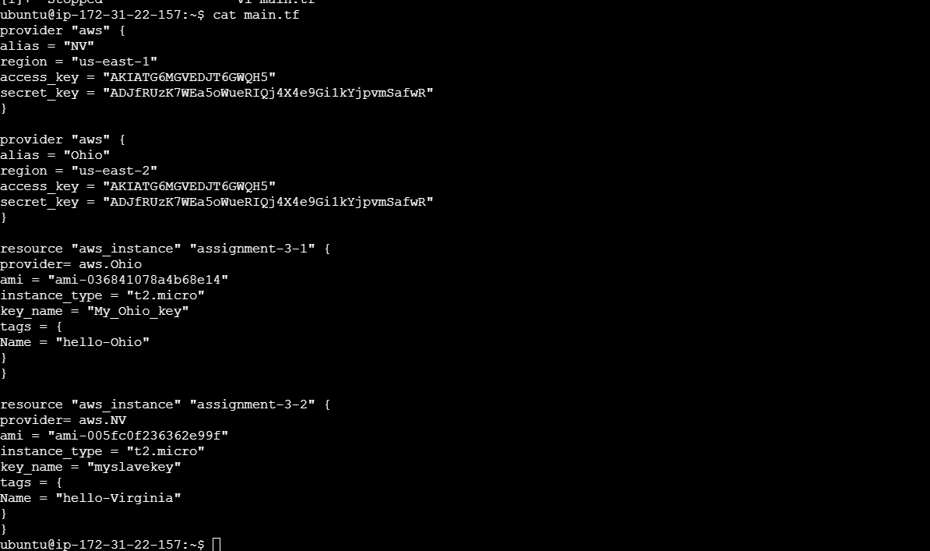

Terraform init

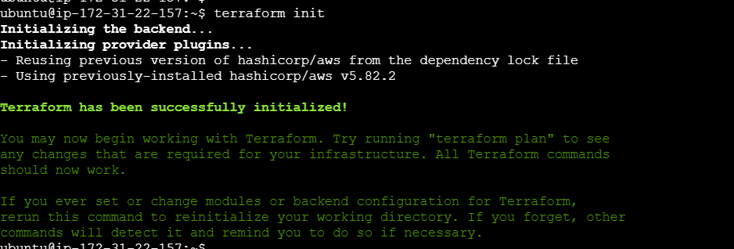

Terraform plan

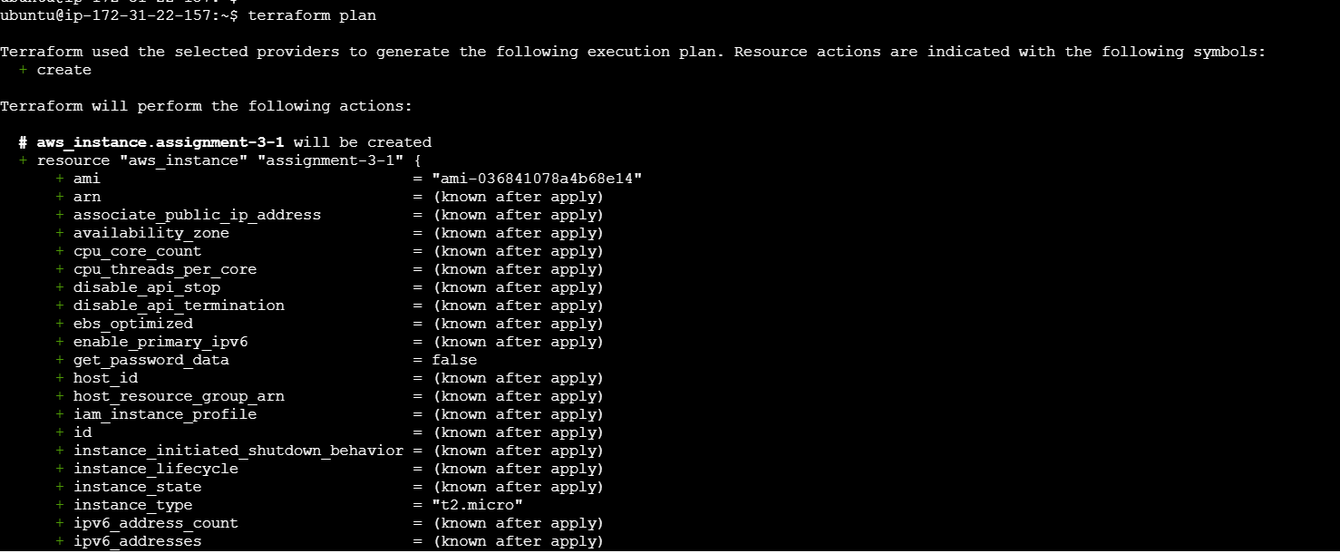

Terraform apply

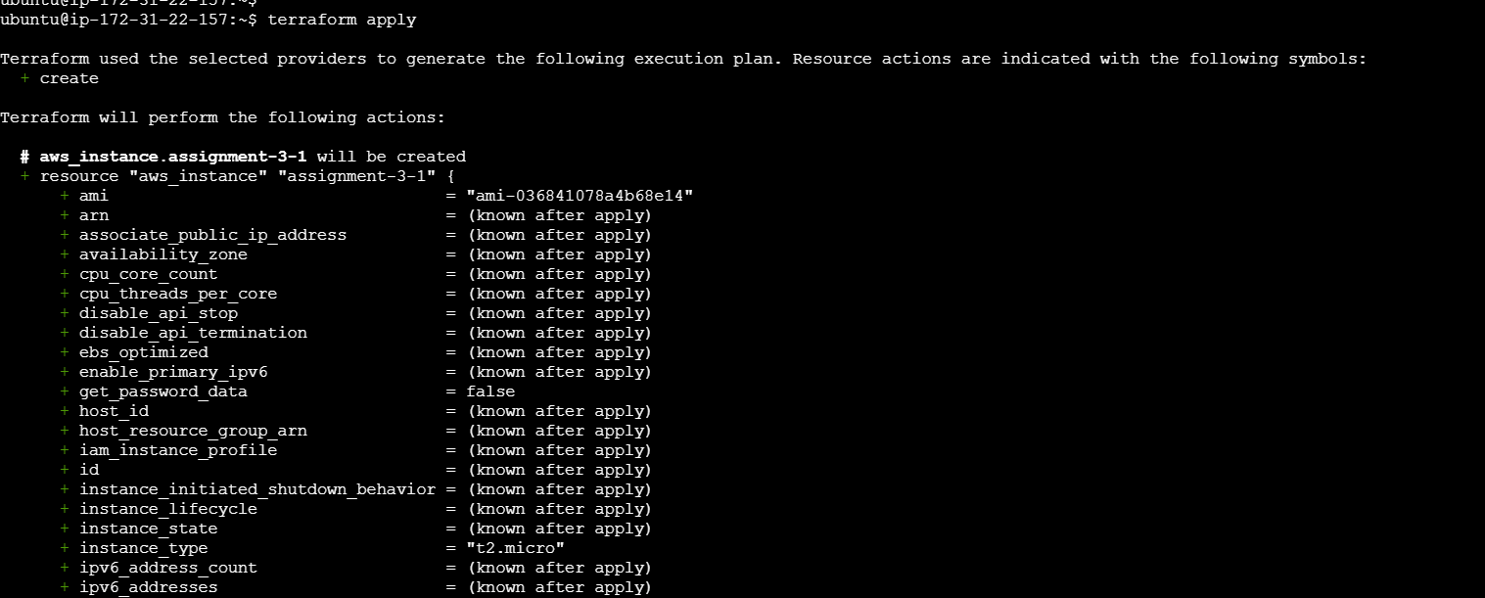

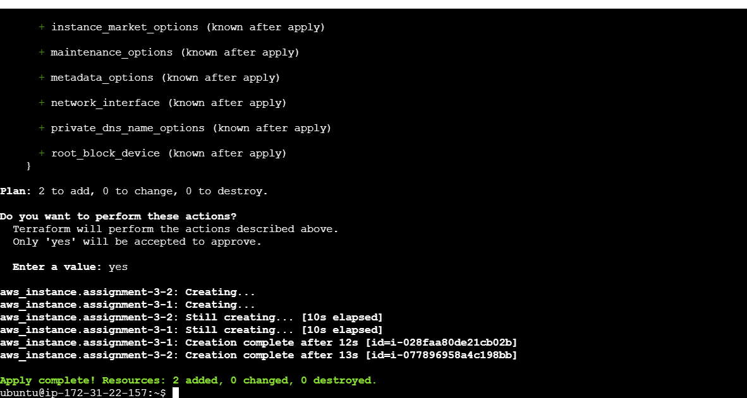

In N.Verfinia Region

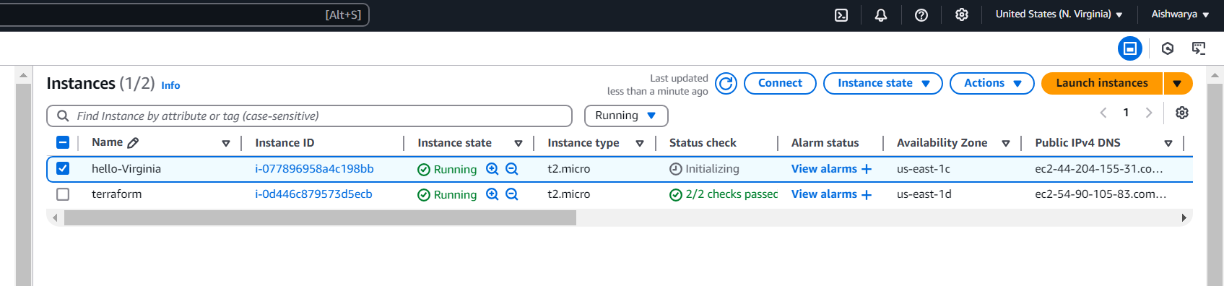

In Ohio Region

